Assignment -3

Build CNN model for classification of Flowers

|  |  |
| --- | --- |
| Assignment Date | 28 October 2022 |
| Team ID | PNT2022TMID54140 |
| Project Name | AI BASED DISCOURSE FOR BANKING INDUSTRY |
| Student Name | SIDDHTARTH.D |
| Student Roll Number | 310619205099 |
| Maximum Marks | 2 Marks |

# **Question-1.** Load the dataset

Solution:

!unzip Flowers-Dataset.zip

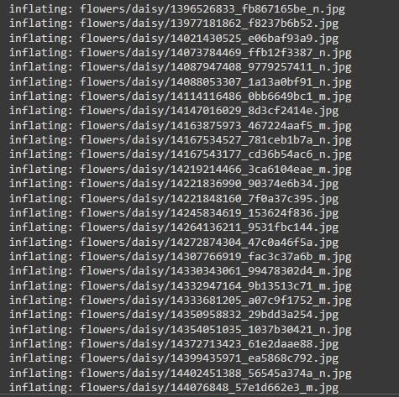

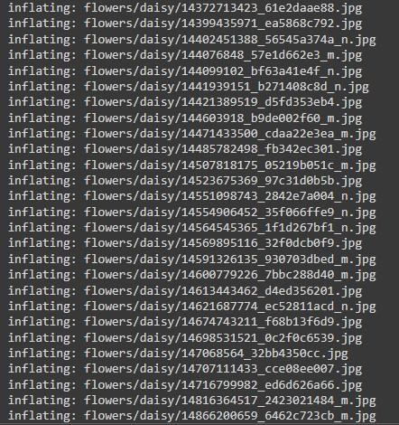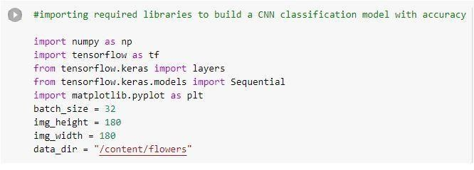

# **Question-2.** Image Augmentation

Solution:

from tensorflow.keras.preprocessing.image import ImageDataGenerator

train_datagen = ImageDataGenerator(rescale = 1./255, horizontal_flip = True, vertical_flip = True, z

oom_range = 0.2)

x_train = train_datagen.flow_from_directory(r"/content/flowers", target_size = (64,64) , class_mode = "categorical", batch_size = 100)

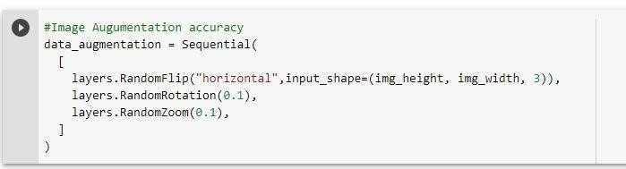

# **Question-3.** Create model - Model Building and also Split dataset into training and testing sets

Solution:

from tensorflow.keras.models import Sequential

from tensorflow.keras.layers import Convolution2D,MaxPooling2D,Flatten,Dense model = Sequential()

train_ds = tf.keras.utils.image_dataset_from_directory(

data_dir, validation_split=0.2, subset="training", seed=123, image_size=(img_height, img_width), batch_size=batch_size)



val_ds = tf.keras.utils.image_dataset_from_directory(

data_dir, validation_split=0.2, subset="validation", seed=123,

image_size=(img_height, img_width),

batch_size=batch_size)



class_names = train_ds.class_names print(class_names)



plt.figure(figsize=(10, 10)) for images, labels in train_ds.take(1): for i in range(9):

ax = plt.subplot(3, 3, i + 1)

plt.imshow(images[i].numpy().astype("uint8"))

plt.title(class_names[labels[i]])

plt.axis("off")

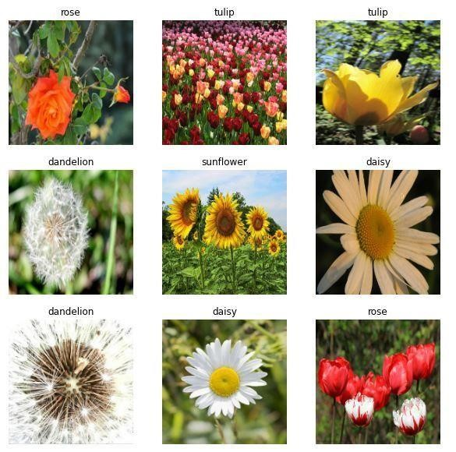

# **Question-4.** Add the layers (Convolution,MaxPooling,Flatten,Dense-(HiddenLayers),Output)

Solution:

model.add(Convolution2D(32, (3,3), activation = "relu", input_shape = (64,64,3) )) model.add(MaxPooling2D(pool_size = (2,2))) model.add(Flatten()) model.add(Dense(300, activation = "relu")) model.add(Dense(150, activation =

"relu")) #mulitple dense layers model.add(Dense(5, activation = "softmax")) #output layer

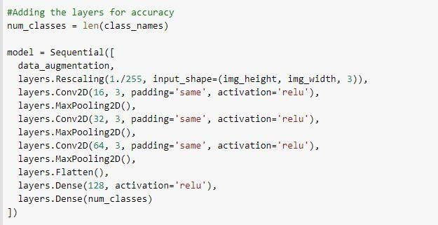

# **Question-5.** Compile The Model

Solution:

model.compile(loss = "categorical_crossentropy", metrics = ["accuracy"], optimizer = "adam")

len(x_train)



# ***#Compile the model for further accuracy***

model.compile(optimizer='adam',

loss=tf.keras.losses.SparseCategoricalCrossentropy(from_logits=True),

metrics=['accuracy'])

epochs=10 history = model.fit( train_ds,

validation_data=val_ds,

epochs=epochs

)

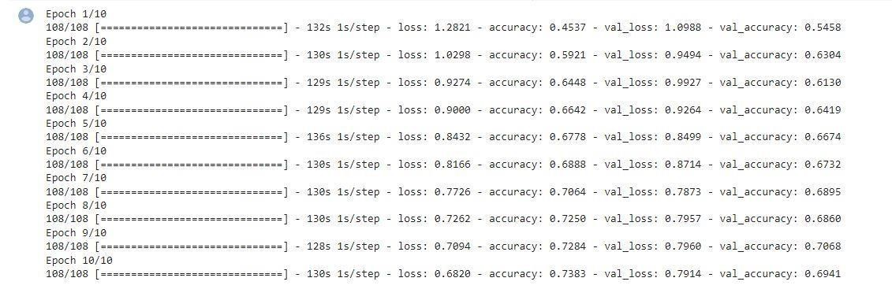

# ***#To find the Training and Validation- Accuracy & Loss (Visualization)***

acc = history.history['accuracy'] val_acc

= history.history['val_accuracy']

loss = history.history['loss'] val_loss

= history.history['val_loss']

epochs_range = range(epochs)

plt.figure(figsize=(8, 8)) plt.subplot(1, 2, 1)

plt.plot(epochs_range, acc, label='Training Accuracy') plt.plot(epochs_range, val_acc, label='Validation Accuracy')

plt.legend(loc='lower right') plt.title('Training and

Validation Accuracy')

plt.subplot(1, 2, 2) plt.plot(epochs_range, loss,

label='Training Loss') plt.plot(epochs_range, val_loss, label='Validation Loss') plt.legend(loc='upper right') plt.title('Training and Validation Loss') plt.show()

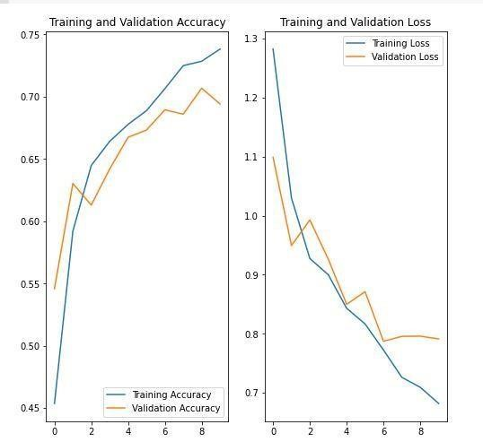

## **Question-6.** Fit The Model

Solution:

model.fit(x_train, epochs = 15, steps_per_epoch = len(x_train))

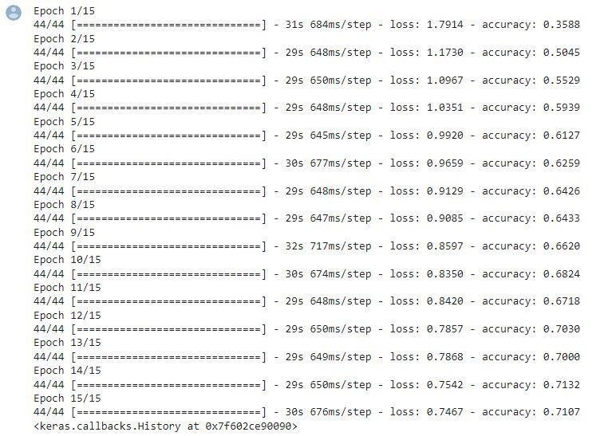

## **Question-7.** Save The Model

Solution:

model.save("flowers.h1")

model.save("flowers.m5")#another model to show the accuracy

## **Question-8.** Test The Model

Solution:

from tensorflow.keras.models import load_model from tensorflow.keras.preprocessing import image import numpy as np

model = load_model("/content/flowers.h1")

# ***# Testing with a random rose image from Google***

img = image.load_img("/content/rose.gif", target_size = (64,64) )

img



x = image.img_to_array(img)

x.ndim



x = np.expand_dims(x,axis = 0)

x.ndim



pred = model.predict(x) pred



labels = ['daisy','dandelion','roses','sunflowers','tulips']

labels[np.argmax(pred)]



# ***#Testing the alternative model with accuracy***

sunflower_url = "https://storage.googleapis.com/download.tensorflow.org/example_images/592

px-Red_sunflower.jpg" sunflower_path = tf.keras.utils.get_file('Red_sunflower',

origin=sunflower_url) img = tf.keras.utils.load_img( sunflower_path, target_size=(img_height, img_width)

)

img_array = tf.keras.utils.img_to_array(img) img_array = tf.expand_dims(img_array, 0) *# Create a batch* predictions

= model.predict(img_array) score = tf.nn.softmax(predictions[0]) print(

"This image most likely belongs to {} with a {:.2f} percent confidence." .format(class_names[np.argmax(score)], 100 * np.max(score))

)

